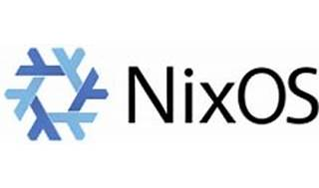



Explore

[**NixOS** is a unique Linux distribution where system configuration is managed declaratively using a single file1](https://discourse.nixos.org/t/companies-using-nixos-technologies-in-2023/32976). It provides reproducibility, atomic upgrades, and a functional package manager.

Here are **five free resources** to learn more about NixOS:

1. [**NixOS Discourse**](https://discourse.nixos.org/t/companies-using-nixos-technologies-in-2023/32976): Explore discussions on companies using NixOS technologies and stay updated on the evolving landscape[1](https://discourse.nixos.org/t/companies-using-nixos-technologies-in-2023/32976).
2. [**Chris Titus’s NixOS Explanation**](https://christitus.com/nixos-explained/): Dive into a detailed video explanation of NixOS, covering topics like virtualization, group management, and more[2](https://christitus.com/nixos-explained/).
3. [**NIX Tech**](https://nixstech.com/): Discover practical training programs and gain knowledge to kickstart your IT career with NixOS[3](https://nixstech.com/).
4. [**StackShare**](https://stackshare.io/nixos): Explore NixOS in tech stacks used by companies like CentralApp, nyris GmbH, and Takt[4](https://stackshare.io/nixos).
5. [**Nixhub.io**](https://xeiaso.net/talks/asg-2023-nixos): Search historical versions of Nix packages and deepen your understanding of NixOS[1](https://discourse.nixos.org/t/companies-using-nixos-technologies-in-2023/32976).

Happy learning! 🚀